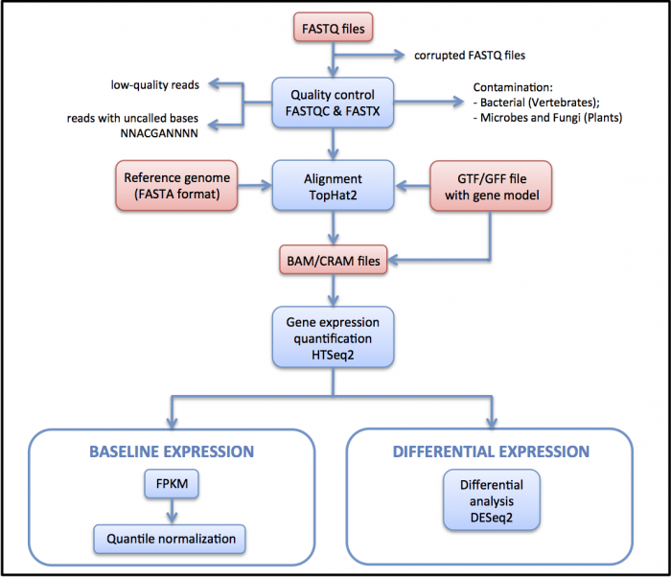
https://www.ebi.ac.uk/training/online/course/functional-genomics-ii-common-technologies-and-data-analysis-methods/differential-gene

or… according to this guide
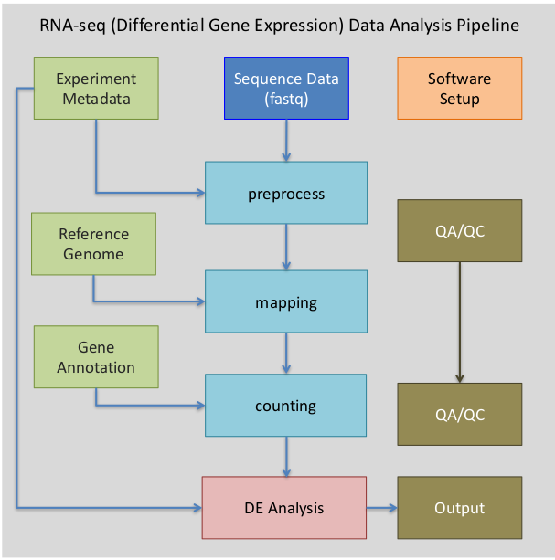

This will be a complete RNA-seq pipeline tutorial.

What is RNA-seq? (link?)
https://www.youtube.com/watch?v=tlf6wYJrwKY

How does an RNA-seq experiment work? (dropdown)

What is this experiment? (dropdown with pictures)
https://www.ncbi.nlm.nih.gov/bioproject/PRJEB26804

This is an overview of the RNA-seq pipeline.
[chart1.png]

Step 1 Getting input files
what is this step? (dropdown with pictures)
what are these files?
fasta stands for "Fast All" and is used for storing reference genome data. [x https://www.rdocumentation.org/packages/bios2mds/versions/1.2.2/topics/export.fasta ]. These files might also use the extension ".fa".
fastq stores genome data along with sequence quality data. [x http://maq.sourceforge.net/fastq.shtml ][x https://bioinformatics.stackexchange.com/questions/14/what-is-the-difference-between-fasta-fastq-and-sam-file-formats#385 ]
gtf stands for "gene transfer format" and is used to store genes and their attributes. [x https://genome.ucsc.edu/FAQ/FAQformat.html#format4 ] These are referred to as "annotations".
SAM stands for "Sequence Alignment Map". SAM files save alignment data of mapped reads against reference genomes. [x http://www.metagenomics.wiki/tools/samtools/bam-sam-file-format ]
BAM stands for "Binary Alignment Map". BAM files contain the same information as SAM files, but stored in binary format. [x https://genome.sph.umich.edu/wiki/BAM ]

In addition to the normal useage shown in the reference page, we will be taking steps to empty the cache. Each time you use fastq-dump. STAR creates a file in the cache to assist the download. But when really large files are downloaded, these files will quickly fill up your cache. So this time, we will be running a command called "cache-mgr" after each call to fastq-dump.
These files will be very large and it will take a while to download all of them.

Step 2 Preprocessing: trimming
what is this step? (dropdown with pictures)
Normally we would do a quality control step called trimming. In low quality reads you will find that the runs are surrounded with the letter "N" repeated for a long time. This means that we don't know what nucleic acids are at those positions. "N" could represent any of them. This means these low quality reads could map to a bunch of different positions they probably don't belong. This would mess up our results in the end.
However, the sequence reads that we're using for this experiment use high quality reads. So we don't need to use trimming in this experiment.

Step 3 Preprocessing indexing
what is this step? (dropdown)
[simple text explanation]

Step 4 Alignment
what is this step? (dropdown with pictures)
Alignment compares individual reads to a reference genome sequence. [x http://journals.plos.org/ploscompbiol/article?id=10.1371/journal.pcbi.1004393 ]
[picture from another alignment guide]
[Figure19-700x527.png ]
[ rna-seq-7-638.jpg ][ https://www.slideshare.net/AmithaDasari/rna-seq-69795083 ]

Step 5 Count based Abundance Estimation
what is this step? (dropdown with pictures)
[x http://htseq.readthedocs.io/en/master/count.html] [picture from here]
In this next step we count the number of reads that map to each gene.

Step 6 Differential expression?
what is this step? (dropdown with pictures)
We will be analyzing the count data.
This will be done in the program R. So the following commands probably won't work as a shell script. You'll just have to copy and paste them into the command line. Be warned that copying and pasting too many of these commands at once might confuse the program. So just take this part slowly.
The following has been adapted from [ https://bioinformatics.uconn.edu/resources-and-events/tutorials-2/rna-seq-tutorial-with-reference-genome/ ]

Now we must enter the conditions. "Treated with vehicle" means the sample was treated with the same solvent [x http://www.protocol-online.org/biology-forums/posts/36366.html] that it was cultured on. So it's control group.
Treatment naive means the cells are from a patient that has never undergone treatment for a certain illness.[x https://www.verywellhealth.com/treatment-naive-3132655 ]

Step 7 Visualization
what is this step? (dropdown with pictures)
[pictures I got from using DESeq2]

Extra (dropdown)
All the previous steps only covered an experiment using just the control group. We saw the gene expression differences between the resistant model and the treatment naive model. Now for those of you that want to try running a more complete experiment, keep going from here. This will be a more complete experiment using the control treated models and the models treated with PARP inhibitor.
First we need to download all the extra files and run them through the same process to get the counts. This will take a very, very long time. So I recommend that you create a script of the following commands. Be careful to adjust the script to match your setup as we did in all the previous steps. You don't want to find out that the script that took all night to run got stuck because of an error.
[cleanRun3extra1.sh]
Now we have the count data from untreated and treated runs. The analysis and visualization process will be similar to before. You will be able to see the difference the treatment group creates.
[cleanRun3graph2.sh]

You can use R to try different analysis strategies. You can use Rstudio [ https://www.rstudio.com/products/rstudio/download/ ] on your own computer. It's availible for Mac and Windows unlike many of the other programs in our RNA-seq pipeline.
another RNA-seq pipeline.

Step 1 Getting input files
SRAtoolkit

Step 2 Preprocessing: trimming
no trimming again.

Step 3 Preprocessing indexing
bowtie ?
http://bowtie-bio.sourceforge.net/manual.shtml#the-bowtie-build-indexer
http://bowtie-bio.sourceforge.net/tutorial.shtml#newi

Step 4 Alignment
tophat?
https://ccb.jhu.edu/software/tophat/index.shtml
https://ccb.jhu.edu/software/tophat/manual.shtml

Step 5 Count based Abundance Estimation
bedtools?
http://bedtools.readthedocs.io/en/latest/content/tools/bamtobed.html
https://www.dnastar.com/seqman_ngen_help/index.html#!Documents/makeacustombedfile.htm
http://genome.ucsc.edu/FAQ/FAQformat#format1
http://bedtools.readthedocs.io/en/latest/content/example-usage.html

Step 6 Differential expression?
bedtools some more
http://bedtools.readthedocs.io/en/latest/content/tools/intersect.html
http://quinlanlab.org/tutorials/bedtools/bedtools.html

